Ecotours GiveAway & American Bird Expo from 29September 2017  Ecotours - Kondor EcoLodge  The original & only registered Ecotours in Hungary - offices at 2 continents |   Europe, Latin America, Africa
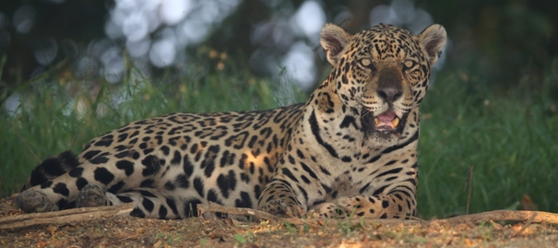

Dear Ecotours Travellers & Friends,
First of all many thanks for spending with us some minutes at the British BirdFair at Rutland Waters, UK during the third weekend of August. This was our 18th BirdFair and was so great to meet with all of you!
Since we sent you a Newsletter in August we do not want to bore you with loads of things again, but there are a few special announcements which we would like to share with you:
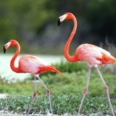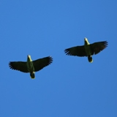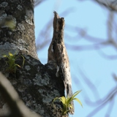
1. GIVE AWAY ANNOUNCEMENT
We are thrilled to announce that our Mayan Birding, Wildlife and Culture program has been nominated as an Unordinary Trip of the Month by InfoHub.com, the #1 travel portal on the Internet specialized in the out-of-ordinary vacations. Passionate about birdwatching and wildlife in general, we see this as a good opportunity to further popularize this form of leisure and to generate awareness in people of the eco issues.
In light of this, we are glad to offer our guests a special prize! Any of you who book the above tour before September 15, 2017 may be eligible for a very special prize from InfoHub's sister-company GPSmyCity - publisher of travel apps for Apple and Android. The GPSmyCity app features offline city maps, self-guided walking tours and travel articles for 1,000 cities worldwide, using which you can turn your mobile into a personal tour guide. With this app you can explore any major urban destination in the world on your own, at your own pace. The GPSmyCity app works offline so there's NO need to worry about roaming charges when traveling abroad.
A lucky winner will be chosen at random to get a one-year full membership of the GPSmyCity app including access to ALL the GPSmyCity content - over 6,500 self-guided city walks and travel articles – to the total value of over $8,000!!!
Book now and enjoy your bird-watching, wildlife and cultural adventure!
We have several flexible dates, different itineraries and very attractive prices!
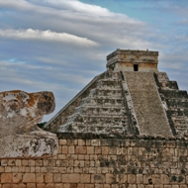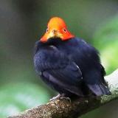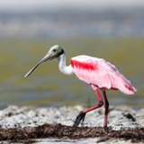
2. AMERICAN BIRD EXPO 29Sept-1Oct, 2017
A bit more than 3 weeks and we will be in Philadelphia as exhibitors for the 3rd time at ABE. We would love to meet with you there where we will wait for you with special offers regarding our Kondor EcoLodge in Hungary, other Eastern European, Latin American and Worldwide destinations. Good birding and wildlife experiences with a touch of culture, tasty local food and memorable wine.
3. LAST MINUTE NEWS
GEORGIA - Incredible Raptor Migration & Caucasian Endemics
4-12October, 2017- 9days at USD1549+USD149 single room supplement
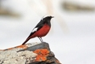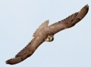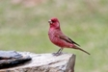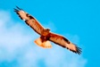
HUNGARY - 100thousand of Cranes & masses of Geese & many other East European specialitie
7-14October & 4-11November, 2017 8days at USD1199+USD199 single room supplement

BRAZIL - Jaguars, Jabirus & other Jewels of Pantanal & Mato Grosso
22Oct till 3November, 2017 USD4759+USD500 single room supplement
This tour is FULL, but we started to accept prebookings for 2018 with similar dates!

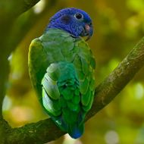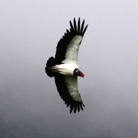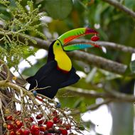PANAMA - Stunning Raptor Migration & Top Tropical Birding
10-19November, 2017 10days at USD2499+USD350 single room supplement

We can hit a BIG DAY with 1.2 million Raptors literally in front of us within a few hours. It is surely an unforgettable experience for everybody! We spend also some days with finding tropical rarities, such as Purple-throated Fruitcrow, Lovely Cotinga, Brownish Twistwing, Rosy Thrush-Tanager, several species of Antshrikes, Antwrens, Antbirds and Black-faced Ant-thrush & Streak-chested Antpitta. Alongside the coast and other watery habitats we can find a wide variety of herons, egrets, shorebirds & others, including Cocoi, Agami & Boat-billed Heron, Blue-footed Booby, We can end up with 2 dozens of Raptors, 5 species of Trogons, 3 species of Motmots, Puffbirds & Manakins.

Belize -Belize - tropical forests & marshes with Spectacled Owl, Royal Flycatcher, Agami Heron, Jabiru, Mexican Ant-thrush, Orange breasted Falcon, various Parrots & Hawk-Eagles & many more

For some more photos please visit our FaceBook page, you do not need to be a member to enjoy it!
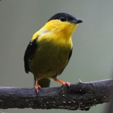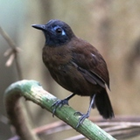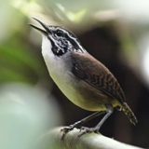
During all of our tours we use Swarovski bins & scopes which you can try at our Kondor EcoLodge, Hungary's first and only natural Swarovski showroom. You can check the quality of the products in our garden or around, focusing on Rollers, Bee-eaters, Orioles or Hoopoes. Try, hire or buy and you will get a special discount from our tours as well.
We offer excellent quality for attractive price in Eastern Europe, Latin America & Worldwide.
All prices above include all the services, single room supplement, but without flight tickets! Please ask for details! All pics were made during our tours!
We hope we can enjoy a great tour together with plenty of wildlife soon!
Get special discounts on some tours if booked before 31December, 2017!!!